# CS 255 System Design Document Template

## UML Diagrams

### UML Use Case Diagram

### UML Activity Diagrams

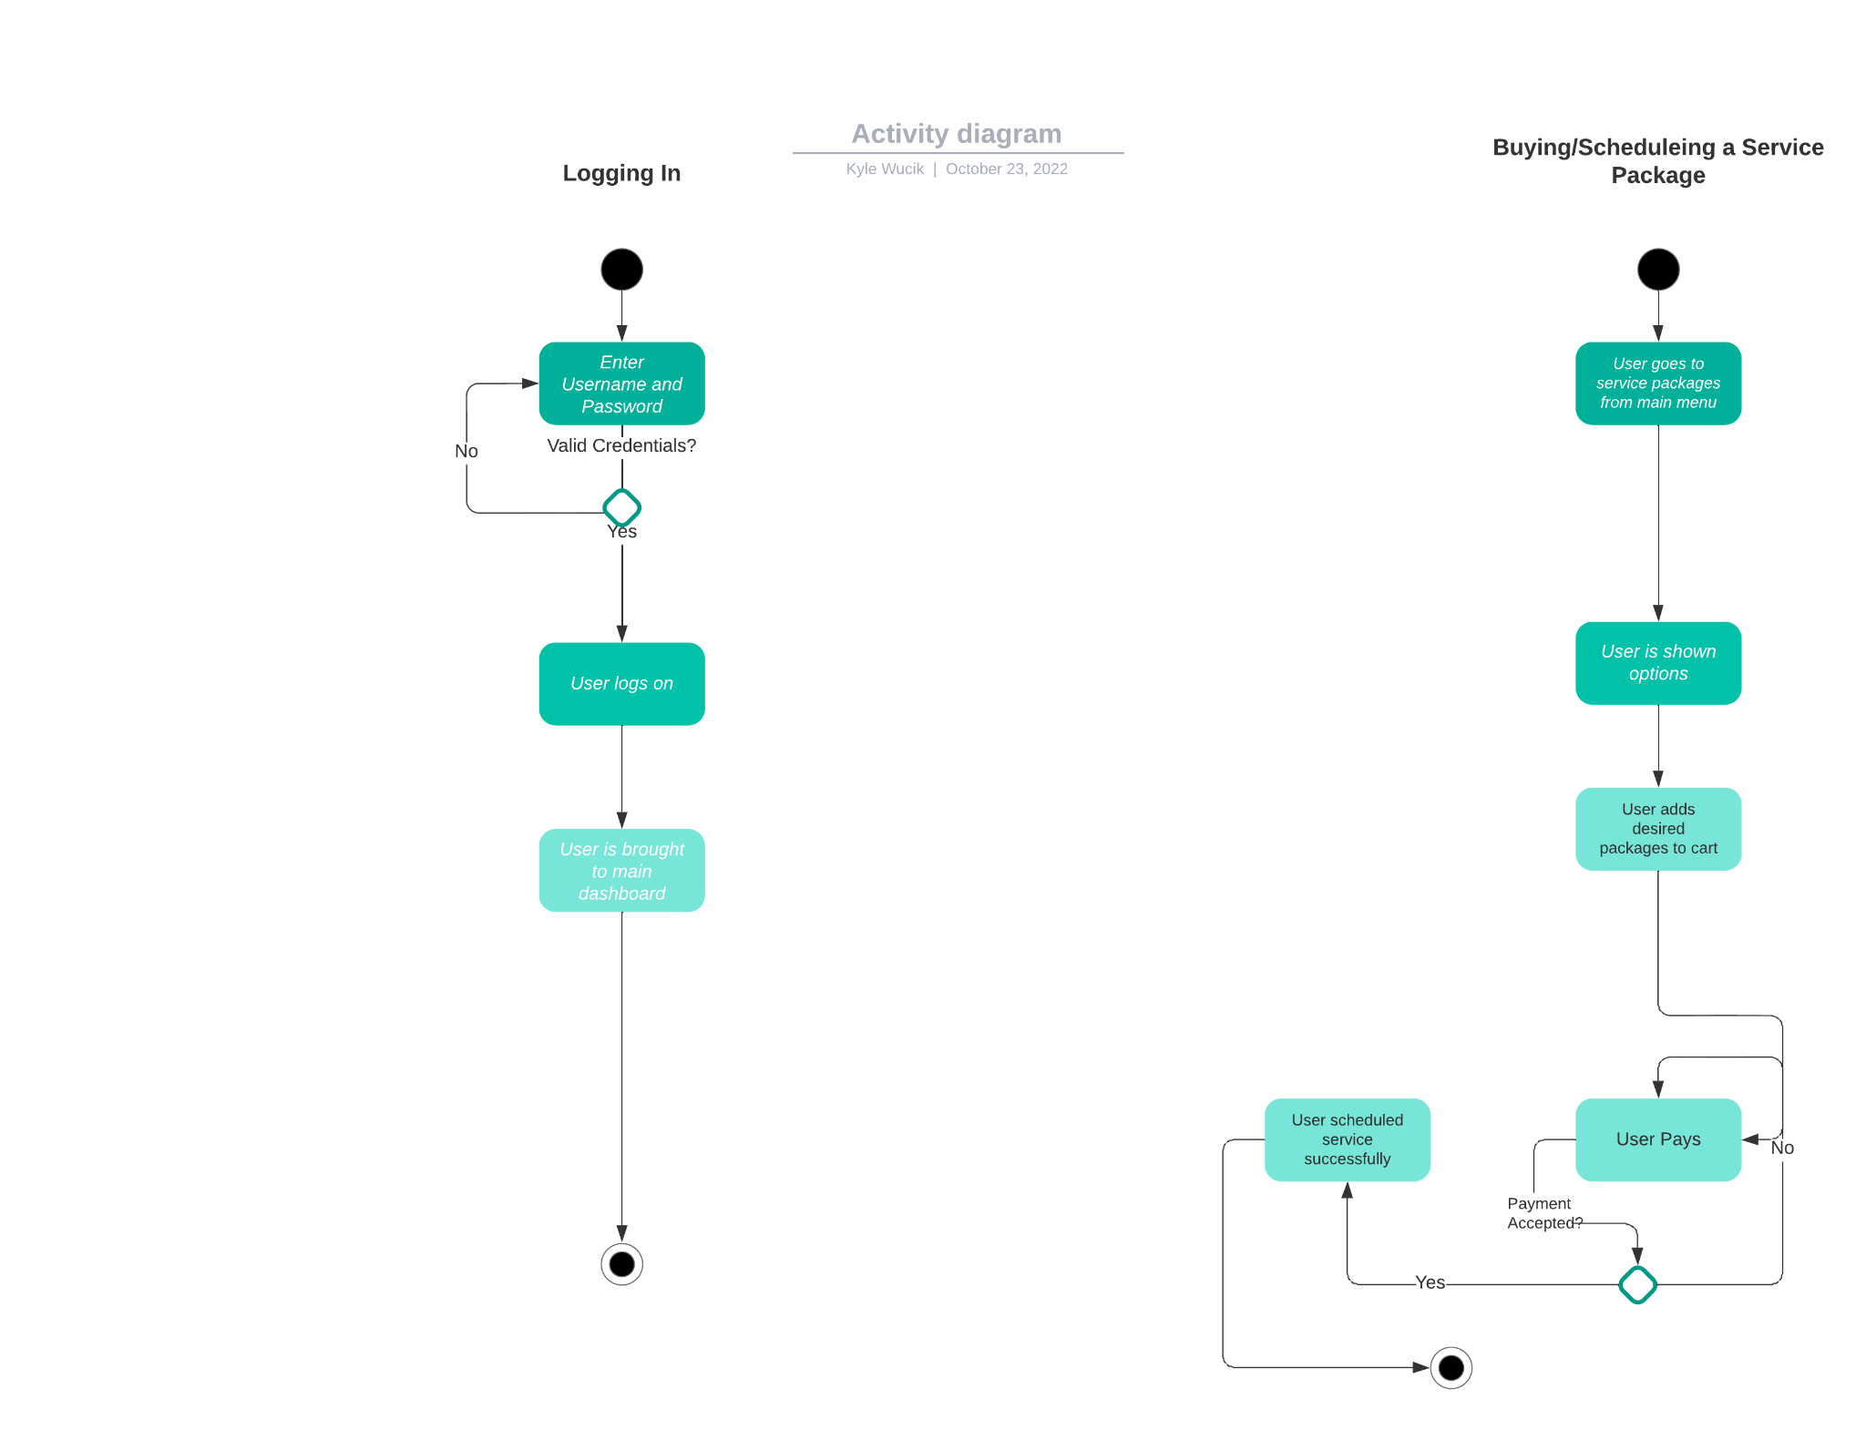

### UML Sequence Diagram

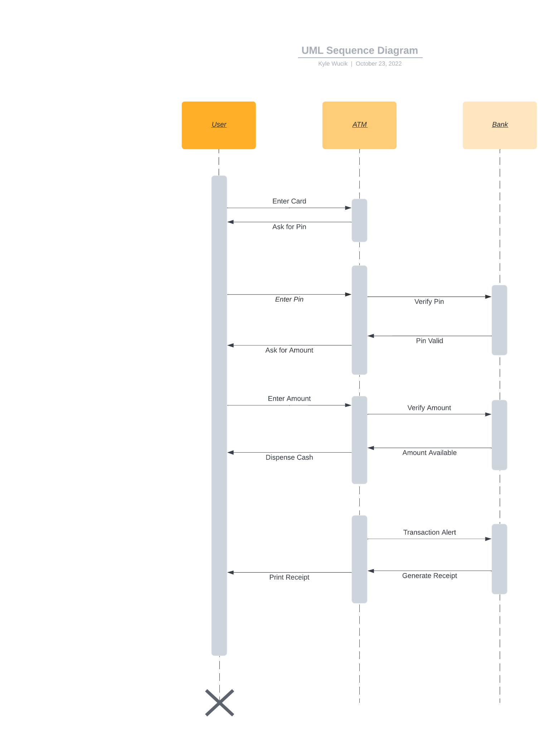

### UML Class Diagram

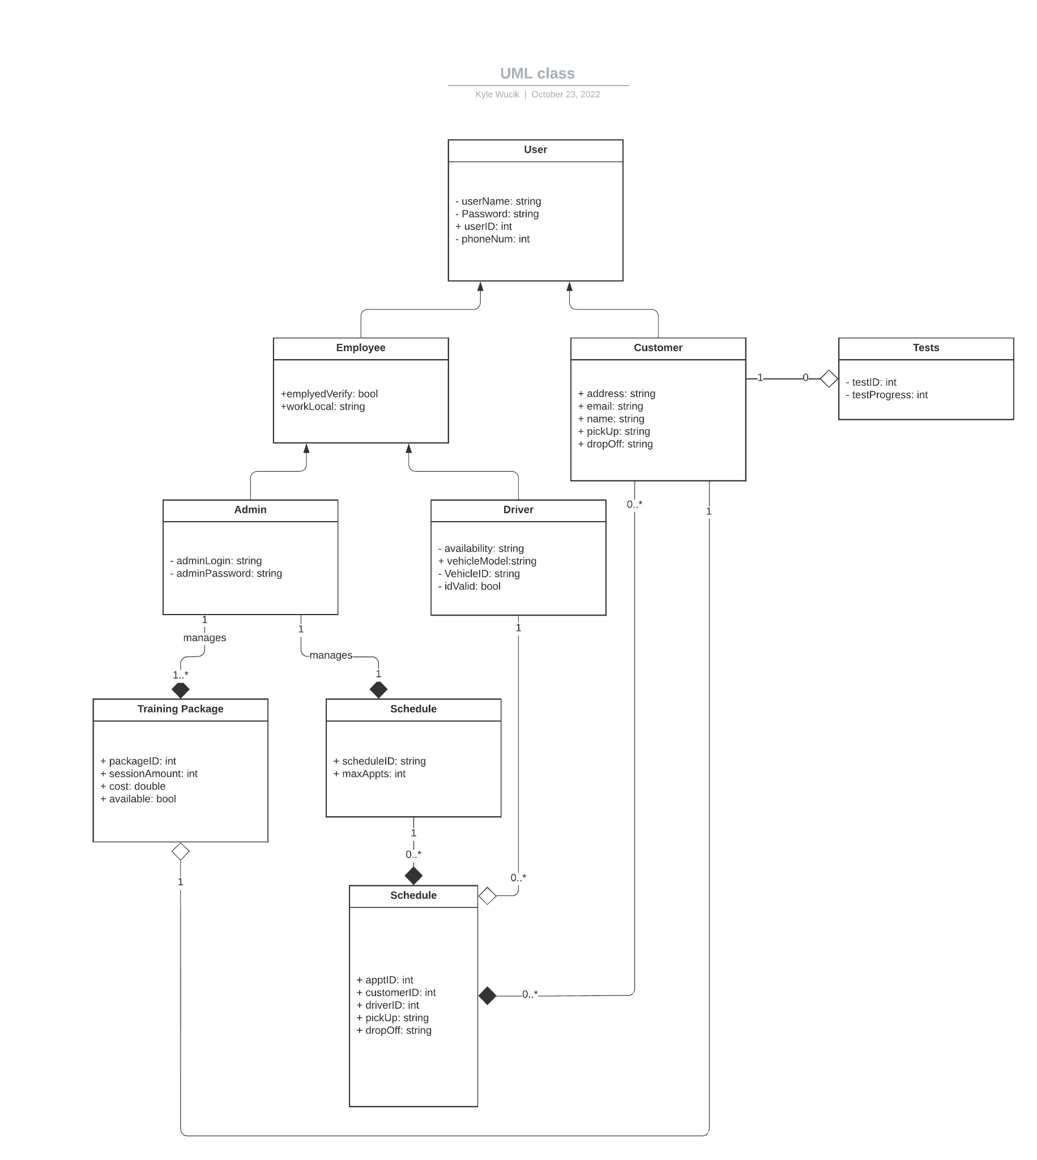

## Technical Requirements

*DriverPass will be a web-based application that is available to all home computers and will later come to mobile devices. It will be a cloud-based website and will be created with HTML, CSS, and Python. No tools, besides log in information is required from the customer for them to use the system.*